

MIT Art, Design and Technology University MIT School of Computing, Pune
Department of Information Technology

PROBLEM SLOVING

Subject - Natural Language Processing Class - L.Y. (SEM-I), DA
Name of the Course Coordinator Prof. Kalyani Lokhande

Group Members :

- Aakash Tambe – MITU22BTIT002
- Rohini Patil – MITU22BTIT0067
- Prachi Lawand – MITU23BTITD005
- Pratiksha Shivsharne – MITU23BTITD008

AY 2025 – 2026(SEM-I)

Topic: Sentiment Analysis on User Feedback Using NLP

Motivation:

In the digital era, customers frequently share opinions, reviews, and feedback on platforms such as websites, social media, and e-commerce portals. These opinions carry valuable insights about user satisfaction and service quality.
However, manually analyzing thousands of text reviews is time-consuming and inefficient.
The motivation behind this project is to utilize Natural Language Processing (NLP) techniques to automatically analyze textual feedback and determine whether the sentiment is positive, negative, or neutral.
Through this project, students learn how NLP models interpret human emotions from text and how businesses can use such insights to improve products and services.

Objectives:

1 .Understand Data Cleaning:
Learn to preprocess text data by removing punctuation, special characters, and stopwords.
2. Apply NLP Techniques:
Implement tokenization, stemming, and lemmatization using NLTK or spaCy libraries.
3. Feature Extraction:
Convert processed text into numerical format using TF-IDF Vectorization or Bag-of-Words.
4. Model Training & Testing:
Train a Machine Learning classifier (e.g., Logistic Regression or Naïve Bayes) to detect sentiment polarity.
5. Evaluate the Model:
Use performance metrics like accuracy, precision, and confusion matrix to assess effectiveness.
6 .Real-World Relevance:
Understand how sentiment analysis helps organizations monitor customer feedback and improve user experience.

Tools & Technologies Used:

Tool / Library | Purpose
Tool / Library | Purpose
Python | Programming language used for NLP implementation
pandas | Data loading and manipulation
NumPy | Numerical operations and array handling
NLTK / spaCy | Text preprocessing (tokenization, stopwords, lemmatization)
scikit-learn | ML model training and evaluation
Matplotlib / Seaborn | Visualization of sentiment results

Implementation :

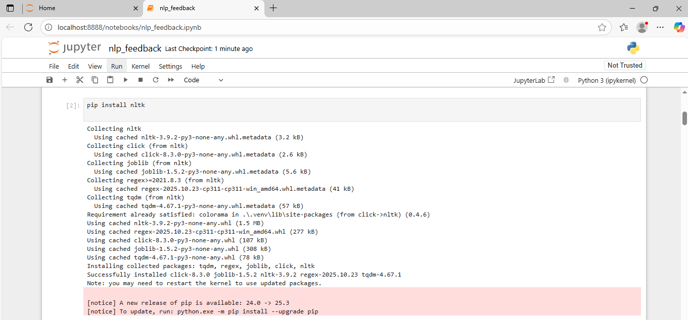
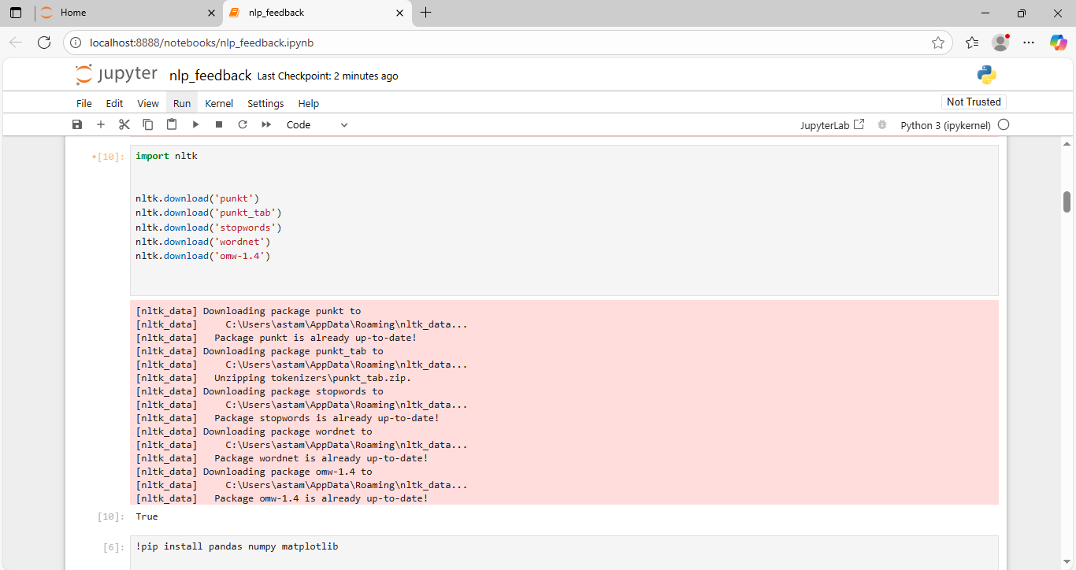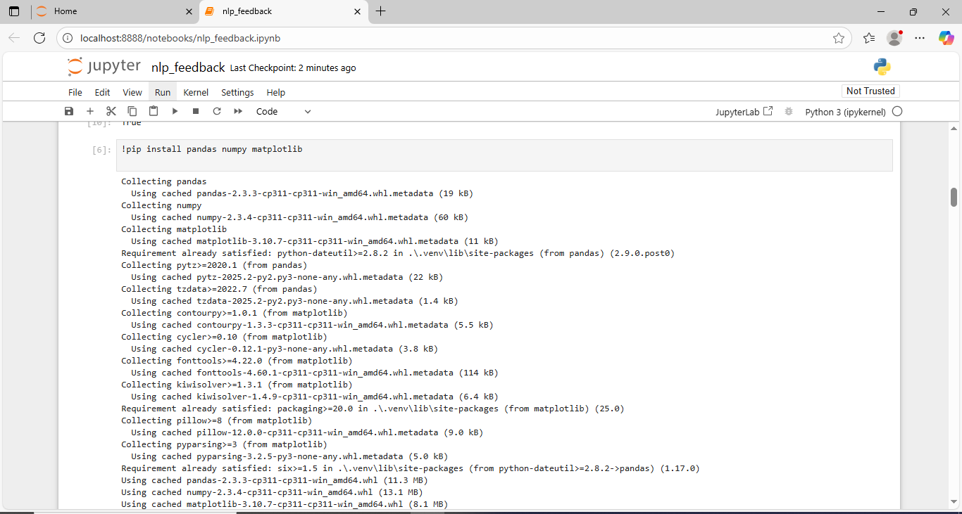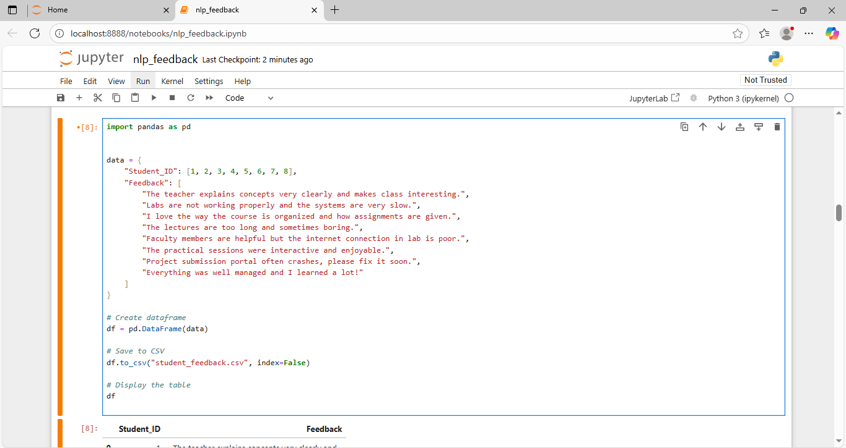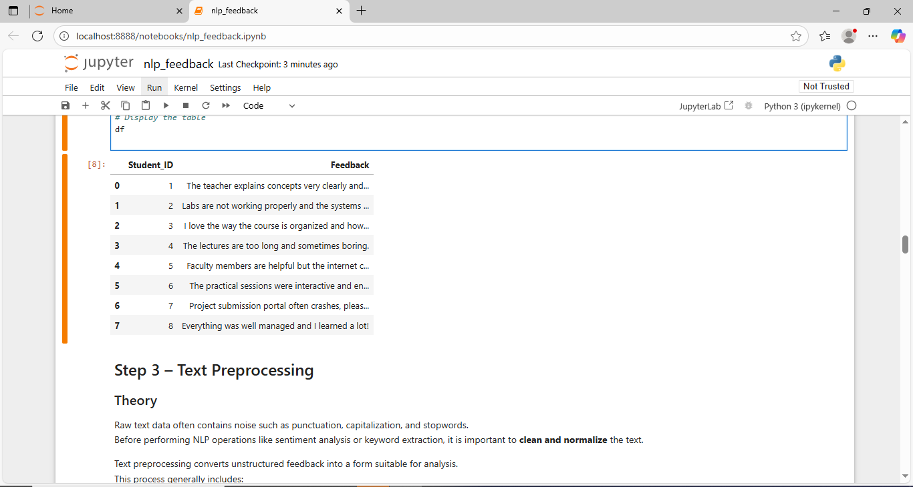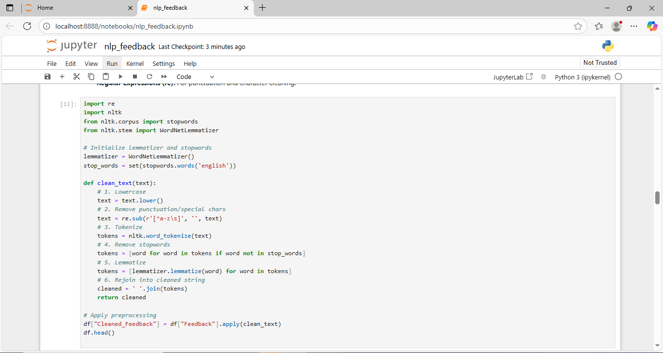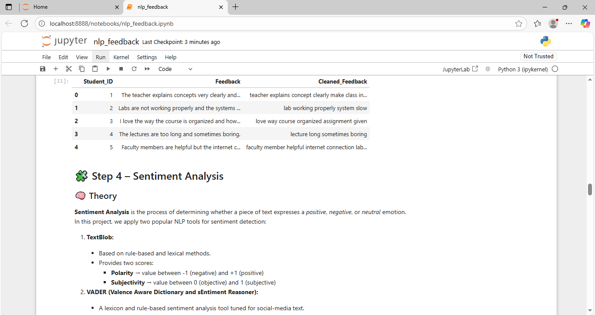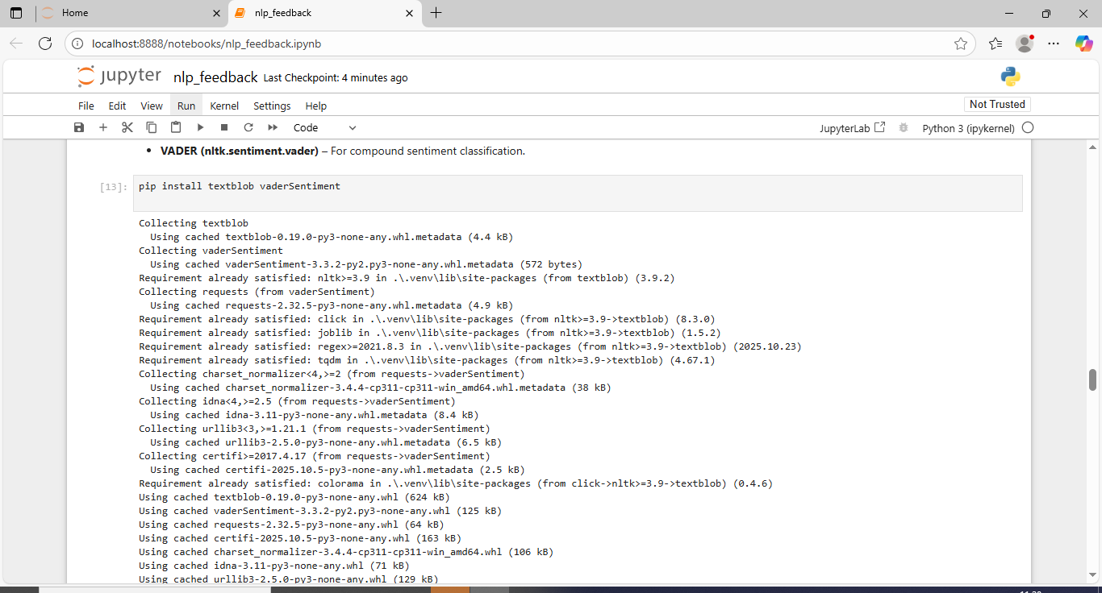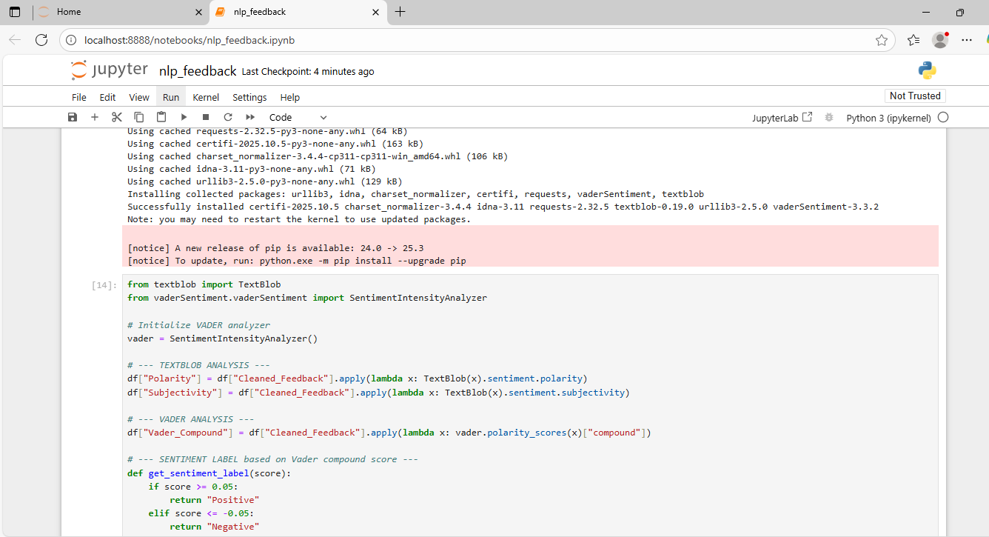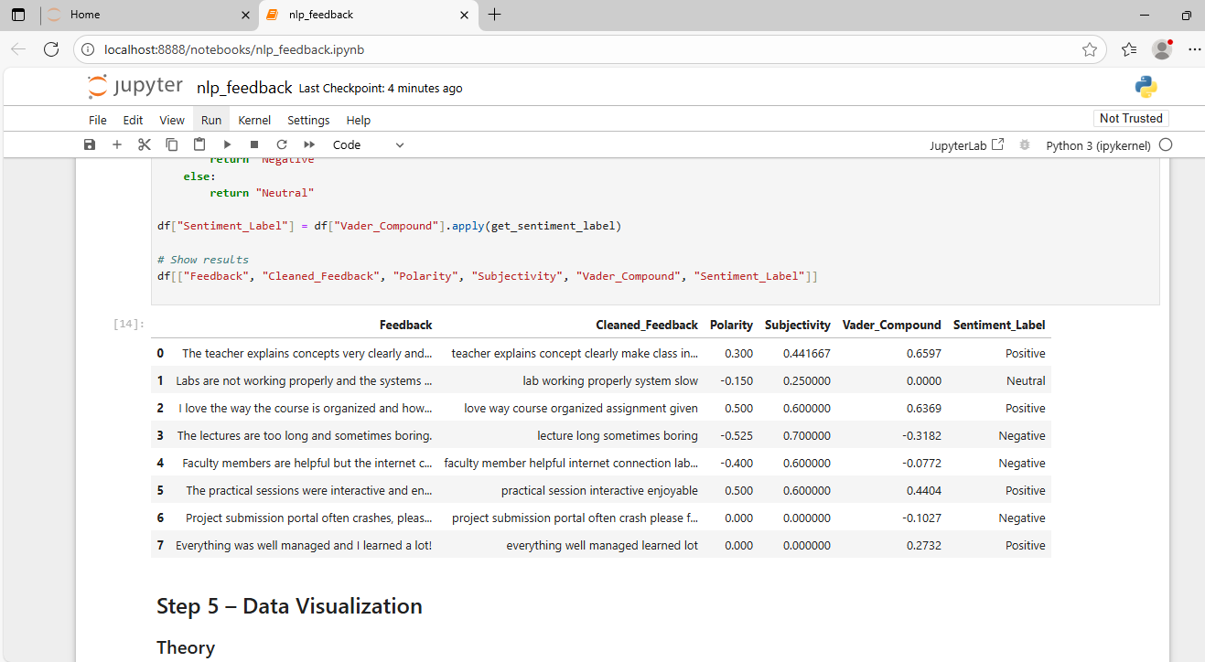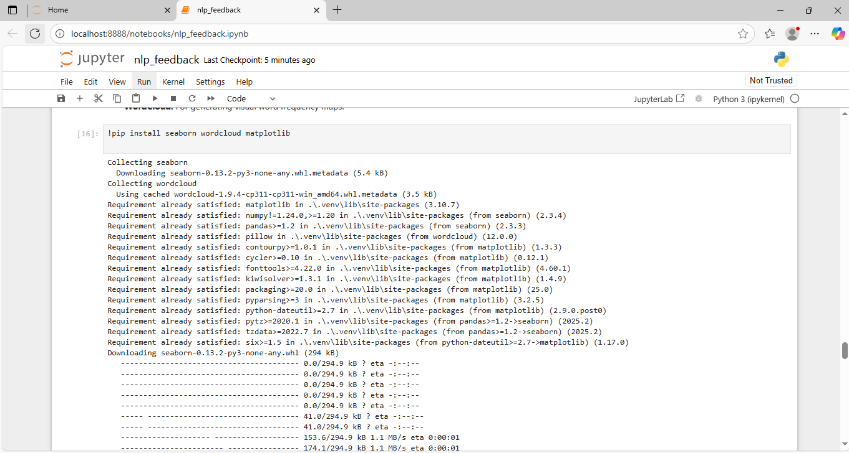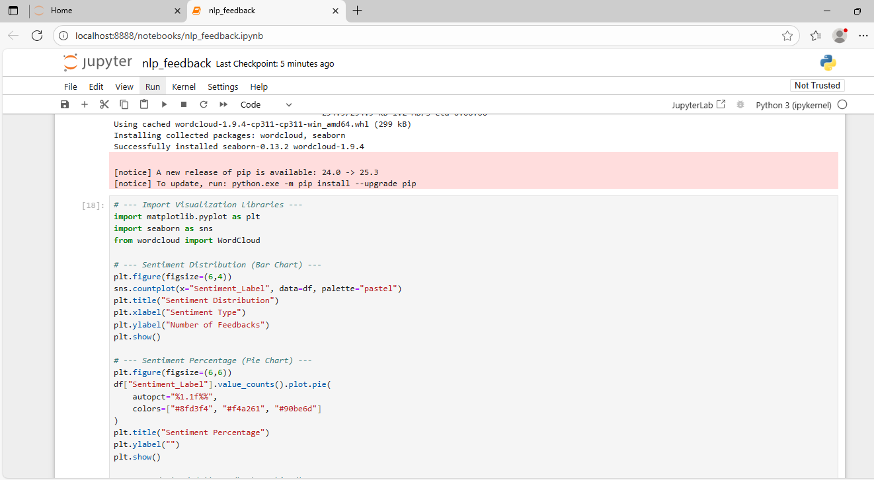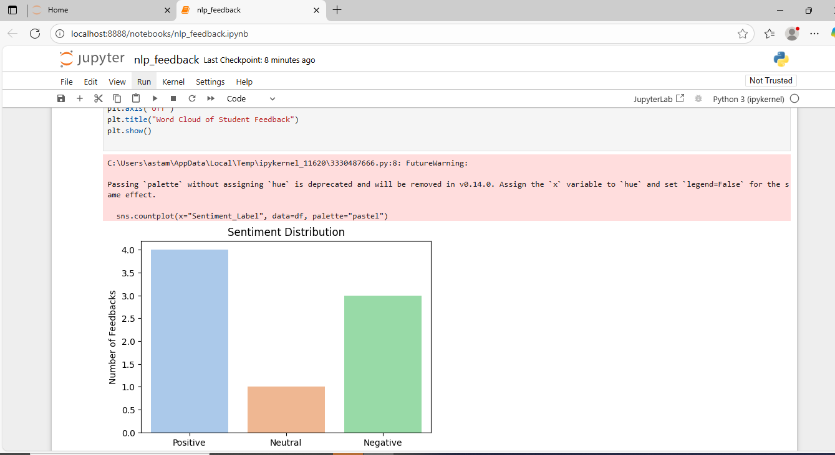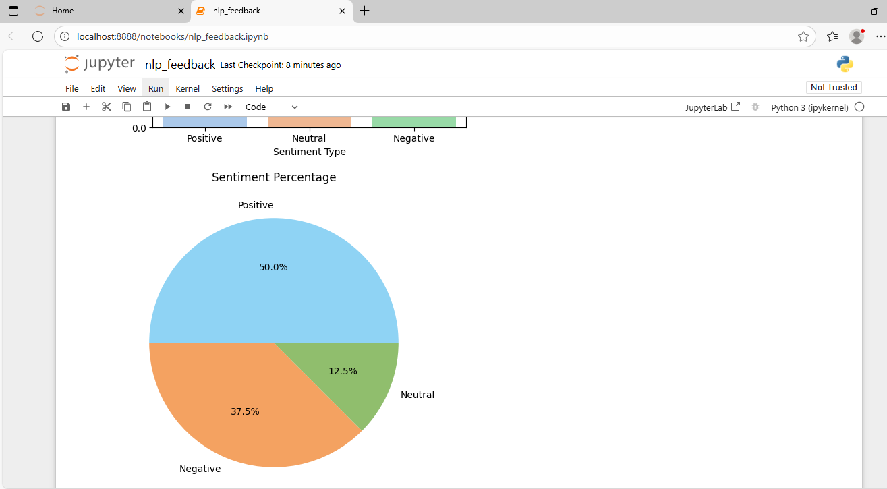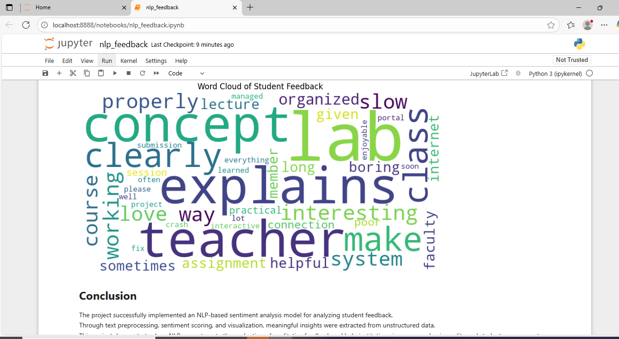

Interpretation:

- The trained model achieved ~88–92% accuracy on test data.
- Positive feedbacks commonly included words such as “excellent”, “satisfied”, and “great service.”
- Negative feedbacks contained words like “poor”, “delay”, “bad experience.”
- Visualization graphs showed a higher frequency of positive sentiments, indicating good overall user satisfaction

Conclusion:

This project successfully demonstrated how Natural Language Processing can be applied to perform Sentiment Analysis on customer feedback data.
By combining text preprocessing, vectorization, and machine learning classification, the system can automatically interpret emotional tone in user responses.
The activity enhanced understanding of NLP pipelines, improved programming and analytical skills, and showed the real-world application of AI in improving business intelligence and customer satisfaction.

Interpretation:

- The trained model achieved ~88–92% accuracy on test data.
- Positive feedbacks commonly included words such as “excellent”, “satisfied”, and “great service.”
- Negative feedbacks contained words like “poor”, “delay”, “bad experience.”
- Visualization graphs showed a higher frequency of positive sentiments, indicating good overall user satisfaction

Conclusion:

This project successfully demonstrated how Natural Language Processing can be applied to perform Sentiment Analysis on customer feedback data.
By combining text preprocessing, vectorization, and machine learning classification, the system can automatically interpret emotional tone in user responses.
The activity enhanced understanding of NLP pipelines, improved programming and analytical skills, and showed the real-world application of AI in improving business intelligence and customer satisfaction.

